Unit 3
Sculpture
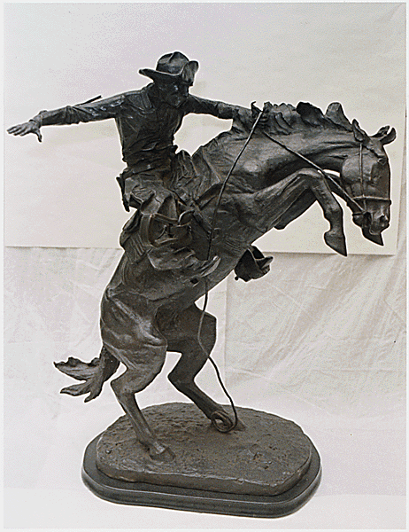
Objectives:
By the end of this unit, you should be able to…
… Identify the materials used to create a sculpture.
...Describe the differences between the four sculpture techniques.
…Use the elements of art to create movement in a wire sculpture.
…Work cooperatively with a group to create a cast of your hand.

Name: _______________________________________________________________________
Art 7 Period ________________________

SCULPTURE VOCABULARY

- Sculpture in the Round / Freestanding Sculpture: _________________
__________________________________________________________________________________________________________________________________________________
- Relief Sculpture: ______________________________________________________
__________________________________________________________________________________________________________________________________________________
- Modeling/Additive:____________________________________________________
__________________________________________________________________________________________________________________________________________________
- Carving/ Subtractive: _________________________________________________
__________________________________________________________________________________________________________________________________________________
- Casting: ________________________________________________________________
__________________________________________________________________________________________________________________________________________________
- Assembling: ___________________________________________________________
__________________________________________________________________________________________________________________________________________________
- Gesture Lines: _________________________________________________________
__________________________________________________________________________________________________________________________________________________
- Armature: _____________________________________________________________
__________________________________________________________________________________________________________________________________________________
IMPORTANT SCULPTURE ARTISTS IN HISTORY
- You will be working in groups of 2 or 3.
- Your group will be assigned one of these artists.
- Together, read through the biographies about your artist.
- Take notes on important facts about your artist, including:
  - Birth
  - Death (if he/she died)
  - Education
  - Important artworks
    - Were the controversial? Why or why not?
    - What are they most famous for?
    - What style is their artwork completed in?
  - What type of sculpture did they do? (Assemblage, carving, etc.)
  - Three interesting facts about your artist.
  - Anything else you think the class should know about your artist.
- You will receive an overhead sheet. Neatly write your notes on the sheet, making sure you have all of the information above. You will present your artist to the class. Any extra work you do (bringing in pictures of their artwork, dressing like the artist, etc.) will earn you extra credit.

Louise Nevelson:
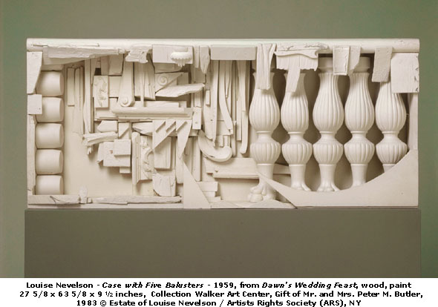
___________________________________________________________________________________________________________________________________________________________________________________________________________________________________________________________________________________________________________________________________________________________________________________________________________________________________________________________________________________________________________________________________________________________________________________________________________________________________________________________________________________________________________________________________________________________________________________________________________________________________________
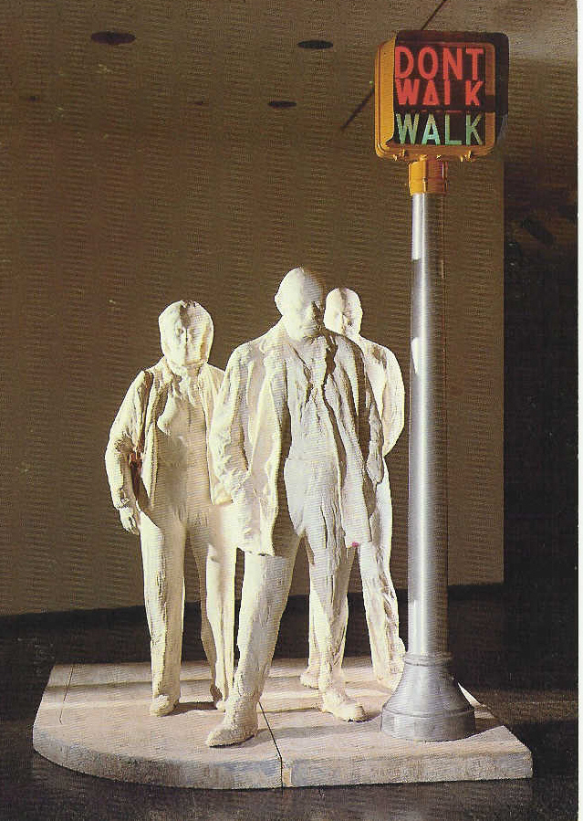
Georges Segal:
________________________________________________________________________________________________________________________________________________________________________________________________________________________________________________________________________________________________________________________________________________________________________________________________________________________________________________________________________________________________________________________________________________________________________________________________________________________________________________________________________________________________________________________________________________________________________________________________________________________________________________________________________________
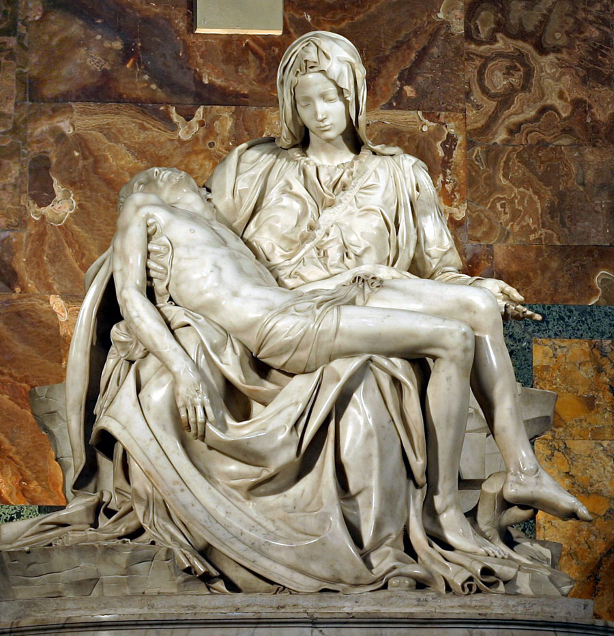
Michelangelo
_______________________________________________________________________________________________________________________________________________________________________________________________________________________________________________________________________________________________________________________________________________________________________________________________________________________________________________________________________________________________________________________________________________________________________________________________________________________________________________________________________________________________________________________________________________________________________________________________________________________________________________________________________________________________
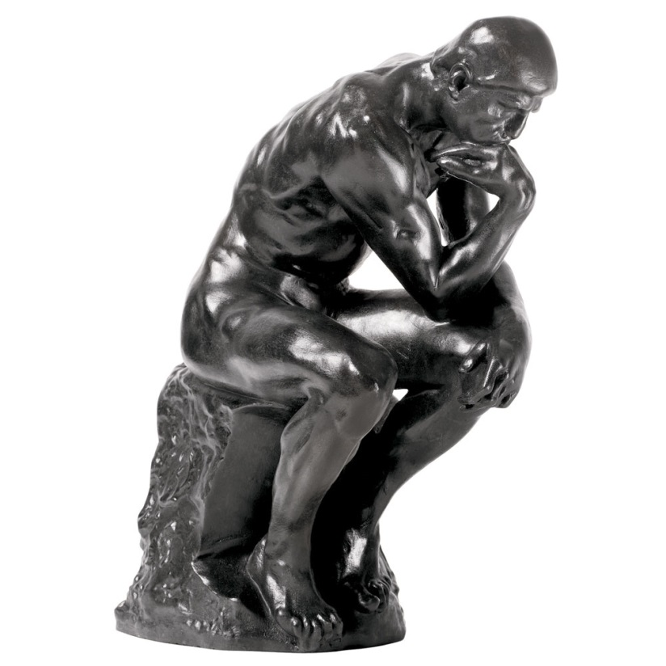
Rodin
__________________________________________________________________________________________________________________________________________________________________________________________________________________________________________________________________________________________________________________________________________________________________________________________________________________________________________________________________________________________________________________________________________________________________________________________________________________________________________________________________________________________________________________________________________________________________________________________________________________________________________________________________________________
Frederick Remington
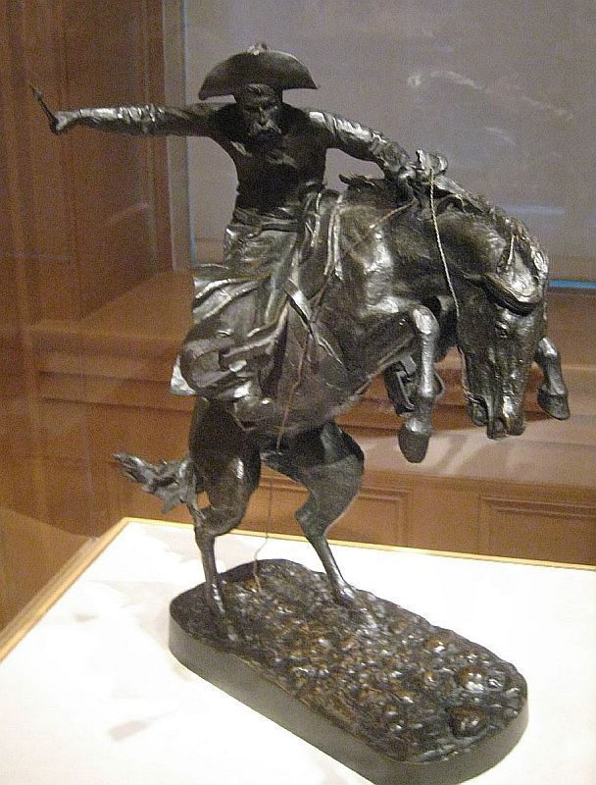
____________________________________________________________________________________________________________________________________________________________________________________________________________________________________________________________________________________________________________________________________________________________________________________________________________________________________________________________________________________________________________________________________________________________________________________________________________________________________________________________________________________________________________________________________________________________________________________________________________________________________________________________________________
Marcel Duchamp
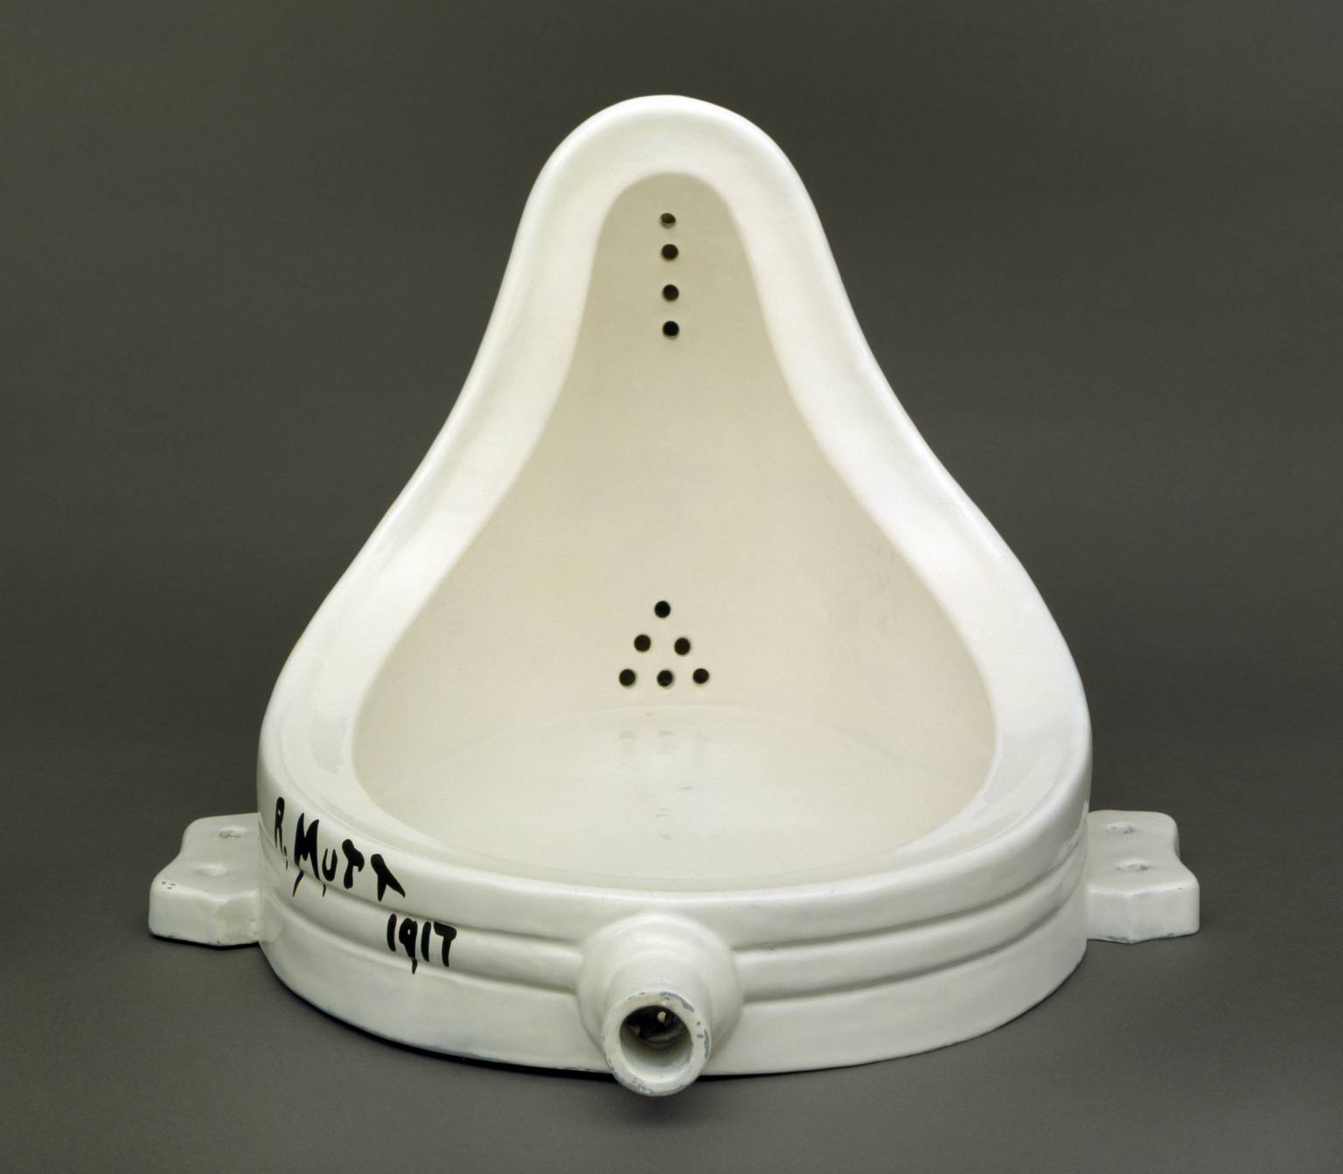
___________________________________________________________________________________________________________________________________________________________________________________________________________________________________________________________________________________________________________________________________________________________________________________________________________________________________________________________________________________________________________________________________________________________________________________________________________________________________________________________________________________________________________________________________________________________________________________________________________________________________________________________________
Claes Oldenburg
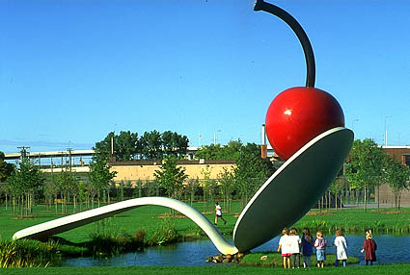
_________________________________________________________________________________________________________________________________________________________________________________________________________________________________________________________________________________________________________________________________________________________________________________________________________________________________________________________________________________________________________________________________________________________________________________________________________________________________________________________________________________________________________________________________________________________________________________________________________________________________________________________________________________________________
Christo & Jeanne Claude
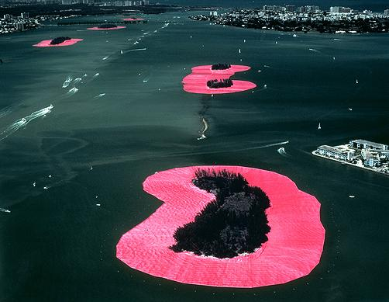
_____________________________________________________________________________________________________________________________________________________________________________________________________________________________________________________________________________________________________________________________________________________________________________________________________________________________________________________________________________________________________________________________________________________________________________________________________________________________________________________________________________________________________________________________________________________________________________________________________________________________________________________
Project #1: Gesture Sculptures
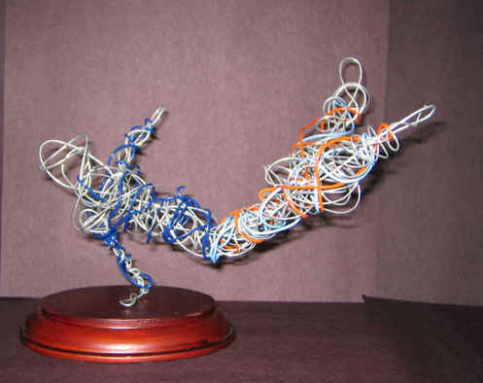
In this project, I can…
- Create the illusion of movement through line.
- Represent the human body using wire.
- Create a free-standing sculpture.

 | 4 | 3 | 2 | 1 | 0
Gesture Planning Sketches: Show movement; drawn from real life.
Figure captures movement
Figure is in correct proportion and is balanced
Creativity; figure is interesting to look at from all sides; did not copy; sculpture is original
Sculpture Base; Student picked a creative and original base for sculpture.
Craftsmanship; Neat, clean, sturdy, and complete.
_________________ / 24 points
4 = Excellent development and understanding; highest quality.
3 = Good development and understanding; high quality.
2 = Limited development and understanding; acceptable quality.
1 = Poor development and understanding; unacceptable quality.
0 =Incomplete
Project #2: Segal Inspired Hand Casts
- You will be working in groups of 2-3. For the first three days of this project, each person in the group will create a cast of their hand using plaster of paris strips. Your arm will be the model and your partner(s) will cover your hand and arm in class with the strips.
- Before covering your arm and hand, wrap your arm with saran wrap. This will prevent the cast from sticking to your arm hair.
- The arm cast must be applied within 15 minutes so that it has 25 minutes to start to dry.
- Once everyone has created a cast, you must decide how to paint it. Use the following page to decide and plan out your design.
- Your cast must be covered in a design. It can be realistic or abstract, letters, a landscape, etc., but it must be thought-out and planned. You may do black and white or color, but if you choose color, make sure you think about your color choices.

Color/Finish Guide
Color/Finish Guide (Use this guide to determine how to finish your sculpture with color and sheen.) Circle the option from each line to start planning your color scheme and design.

I want my piece to be more: Natural / Altered
I want my piece to be more: Warm / Cool
I want More material to show / Less Material to show through the colored surface.
I want my piece to be: Glossy / Semi-glossy / Satin / Flat / Dry
I want my piece to be: Colorful /Neutral
I want my piece to feel: Fun / Serious
I want my piece to be: understated / Pop
I want my piece to look: Aggressive /Passive
I enjoy color harmonies that are: Monochromatic / Triadic / Multiple
Color Hues I am considering are:____________________________________________________
The Hue should be: Saturated / Desaturated
If desaturated, I might consider: Tinting (lighter) / Shading (darker)
Regarding color harmony, my piece is more: Consistent / Varied
I want my piece to be abstract / realistic.
In the space below, start planning out a design that will cover your hand. Be sure to think about the elements and principles of art in your design!

 | 4 | 3 | 2 | 1 | 0
Group Work | Student worked cooperatively in a group setting every day in class. | Student mostly worked cooperatively in a group setting during class. | Student had to be reminded to work cooperatively. | Student did not work in a group but managed to get a hand cast completed. | Student did not work in a group and did not complete a hand cast.
Use of Materials | Student always keeps materials and area clean and protected without reminders. The student shows great respect for the materials and his fellow students. | Student usually cleans materials and work area at the end of the session without reminder, but the area may be messy during the work session. Student shows respect for materials and fellow students. | Student adequately cleans and takes care of materials if reminded. Occasional spills and messy work area may be seen. Shows some respect for materials and fellow students. | Student needs constant reminding to clean and take care of materials. Student’s messy work tendencies affect other students. Shows little respect for materials or fellow students. | Student deliberately misuses materials AND/OR does not adequately clean materials or area when reminded. Shows no respect for materials or fellow students.
Elements & Principles of Art | Students utilized both the elements of art to illustrate their word: line, shape, space, form, value, texture, color, pattern, unity, etc. | Student utilized most of the elements and principles of art to illustrate their word. | Student utilized some of the elements and principles of art to illustrate their word. | Student utilized few of the elements and principles of art to illustrate their word. | Student has no understanding of how to utilize the elements and principles of art and/or made no attempt to utilize them.
Painting Skills | Student used more than one layer of paint in order to create an opaque design. Student excelled at maintaining the design of their artwork. | Student mostly covered the piece with opaque shapes. The design was mostly maintained with very few mistakes. | Student has some opaque shapes and maintained some of the design. Mistakes are visible in their work. Paint is streaky. | Student made many mistakes and very few shapes are opaque. The design lost its form. Parts of the canvas are unpainted where it is meant to be painted. | Unfinished; very sloppily applied paint.
Creativity / Originality | Student has taken the technique being studied and applied it in a way that is totally his/her own. The student's personality/voice comes through. Everything is original. | Student has taken the technique being studied and has used source material as a starting place. The student's personality comes through in parts of the painting. Everything is original. | Student has copied aspects of their artwork from another source and/or there is little evidence of creativity, but the student has done the assignment. | Student has not made much attempt to meet the requirements of the assignment and/or a majority of the assignment has been copied from another source. | No creativity attempted and/or artwork is a direct copy from another source.
Craftsmanship / Effort | Class time was used wisely. Extra time and effort went into the planning. Artwork has been created and maintained in a professional manner. | Class time was used wisely. A satisfactory amount of effort went into the planning. Artwork has been created and maintained in a somewhat professional manner. | Class time was not always used wisely but student got the project finished within the project parameters. Artwork was created and maintained with an attempt at neatness. | A majority of class time was not used wisely and tag was not finished with the project parameters. Artwork was not maintained with an attempt at neatness. | Class time was not used wisely and the student put in no additional effort. Artwork looks unfinished.

